Antiphon
News from the Annapolis Chapter of the AGO

March 2021

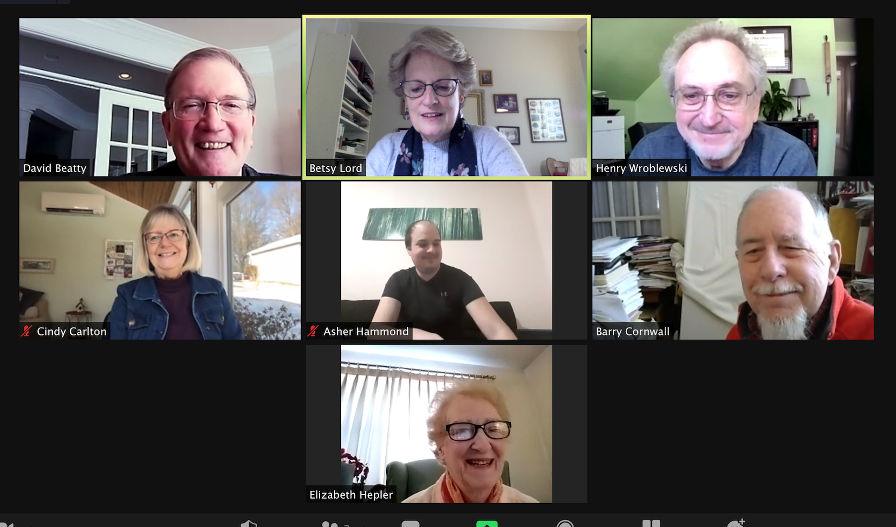
Dear Colleagues,

Thank you, David Beatty, for your presentation on the Hauptwerk organ system. We found it very enlightening, and we are happy to have received your informative PowerPoint presentation. It is loaded with resources and thoughts to ponder!

There is lots of news to share. Leah Murthy will give choir directors new ideas as they look forward to resuming rehearsals. We are also in the process of collecting volunteers who will provide music for our COVID Memorial video project. Please see below for more details.

Please contact me if you have any questions about anything in this newsletter. I look forward to seeing you at our next meeting!

Betsy Lord, Dean

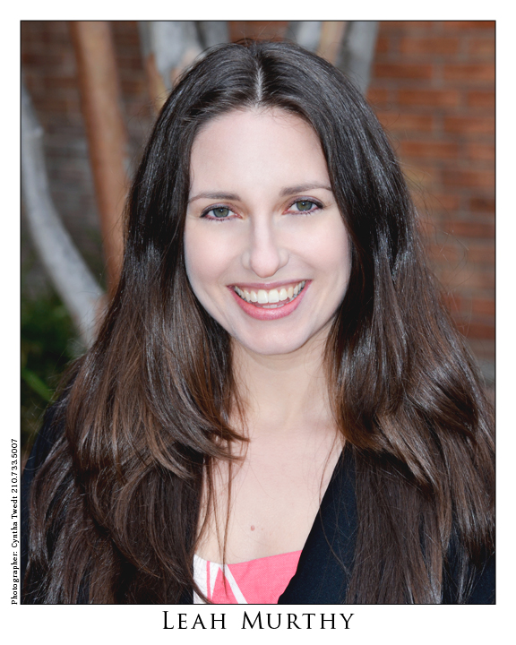
March Meeting

On Sunday, March 21, at 7:00 PM Leah Murthy will present an online Choral Directors’ Workshop, Musicianship in Minutes: Quick and Engaging Additions to Your Choir Rehearsal for Faster Learning and Increased Musicality. Leah is Associate Conductor with the National Children’s Choir in Washington DC and a doctoral candidate in music education at Boston University. Her articles about teaching musicianship in choir rehearsals have been published in The American Organist and in The Chorister (Chorister’s Guild magazine). Choir directors and singers are invited to attend.

We will begin with social time at 6:30, followed by Leah’s workshop at 7:00. Join when you can! Click on the link in the email, or open up zoom and join meeting number 87609226460.

Grief, Comfort, Hope: When Words Fail, Music Speaks

This is the title of the video we will present as a gift to the community in memory of those who have been lost due to the pandemic, and to provide comfort for all who have suffered during the last year. We are seeking a variety of music to include in the video, which will also include prayer, scripture and poetry. Please think about sharing your talents for this project. The deadline to volunteer is March 20. Please refer to the email you received from Sub Dean Henry Wroblewski on February 23.

Member News

Thank you Clarice Snyder for renewing your membership. Did you know that Clarice is a dual member with the Potomac Member Chapter, and that she is the Regional coordinator for Competitions for the Mid-Atlantic Region of the AGO?

Cindy Carlton, the Music Director at St. Thomas Episcopal Church in Croom, MD, has a surprise planned for Easter Sunday. For the first time in a year, the choir will be singing outside a cappella as a full choir. Easter Sunday will feature the music taped ahead with drone footage!

Henry Wroblewski is a math teacher at a Catholic school, and he just finished making a video on the Carmelite saints for the school to use during daily prayer sessions. For his next pect he will produce a virtual drama for the school.

Employing Musicians in Religious Institutions:
A Handbook for Committees and Candidates

This is the title of a 44-page booklet created by the AGO as a resource to replace the AGO’s Salary Guidelines, which used to be available. You can download the document here and take a look: https://www.agohq.org/wp-content/uploads/2021/02/Chapter-Leader-News-February-2021-2.pdf. You can also read AGO Executive Director James Thomashower’s article about this handbook on page 8 of the March issue of The American Organist.

CHAPTER OFFICERS
Dean: Betsy Lord
Sub-Dean: Henry Wroblewski
Secretary: Cindy Carlton
Treasurer: Scott Romanoski

MEMBERS-AT-LARGE
Class of 2021: HyeSung Hwang, Daniel Weatherholt
Class of 2022: Jim Douglas, Jennifer Lewis
Class of 2023: David Beatty, Isaac Borocz

CHAPTER WEBSITE:
Annapolisago.org

